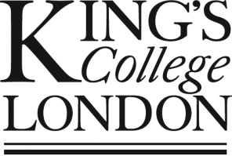**Opportunity for your son/daughter to take part in a research project**

Dear parents,

I am writing to you to invite to seek permission for your son/daughter to take part in a piece of research trailing the effectiveness of using stories in science teaching that forms part of my MA education thesis at King’s College London. Some year nine science classes will receive additional short (1-3 minutes) stories from the history of science or from cutting-edge research in their lessons. Other classes will not. If you choose your son/daughter to participate they will be asked to consent to: a) your son/daughter’s normal science assessment being accessed to monitor their attainment; b) Your son/daughter completing a short survey (8-10) minutes in form time at the start and end of the project; c) two of their science lessons being observed to gauge the engagement of the class. In all reports and publications from the project, the identity of the school, teachers and students will be hidden.

If you are interested in your son/daughter taking part, or have further questions about what participation would involve, please contact me at:

[Jemima.bloggs@kcl.ac.uk](mailto:Jemima.bloggs@kcl.ac.uk)

Best wishes,

Jemima Bloggs.